TASK 1
#include <iostream>
using namespace std;

class Node {
public:
string data;
Node *next;

Node(string t) : data(t), next(nullptr) {}
};

class RollCallSystem {
private:
Node *head, *tail;

public:
RollCallSystem() : head(nullptr), tail(nullptr) {}

void addStudent(string name) {
Node *newNode = new Node(name);
if (!head) {
head = tail = newNode;
} else {
tail->next = newNode;
tail = newNode;
}
cout << "Added: " << name << endl;
}

void deleteStudentByName(string name) {
Node *temp = head, *prev = nullptr;
while (temp && temp->data != name) {
prev = temp;
temp = temp->next;
}
if (!temp) {
cout << "Student with name \"" << name << "\" not found.\n";
return;
}
if (!prev) {
head = head->next;
if (temp == tail) tail = head;
} else {
prev->next = temp->next;
if (temp == tail) tail = prev;
}
delete temp;
cout << "Deleted: " << name << endl;
}

void display() {
Node *temp = head;
int pos = 1;
cout << "\n--- Students ---\n";
while (temp) {
cout << pos << ". " << temp -> data << endl;
temp = temp -> next;
pos++;
}
if (head == nullptr) cout << "(empty)\n";
}

~RollCallSystem() {
while (head) {
Node *temp = head;
head = head -> next;
delete temp;
}
}
};

int main() {
RollCallSystem classroom;

classroom.addStudent("Harry");
classroom.addStudent("Ron");
classroom.addStudent("Hermione");
classroom.addStudent("Draco");
classroom.addStudent("Neville");

classroom.display();

classroom.deleteStudentByName("Draco");
classroom.display();

classroom.deleteStudentByName("Luna");
classroom.display();

return 0;
}

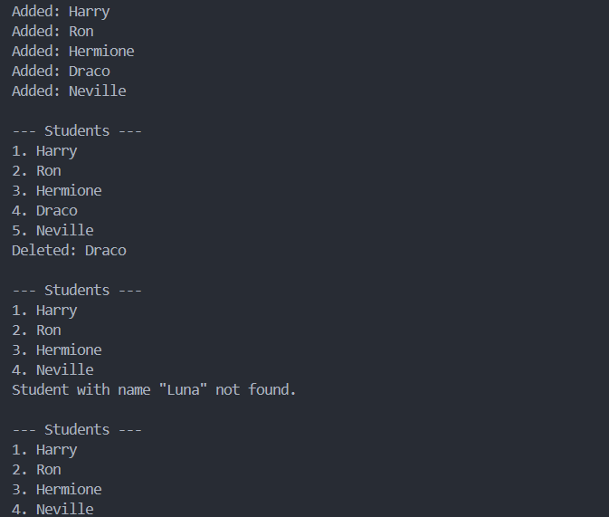

TASK 4
#include <iostream>
using namespace std;

class Node {
public:
string data;
Node *next;

Node(string t) : data(t), next(nullptr) {}
};

class PhotoGallery {
private:
Node *head, *tail;

public:
PhotoGallery() : head(nullptr), tail(nullptr) {}

void addPhoto(string title) {
Node *newNode = new Node(title);
if (!head) {
head = tail = newNode;
} else {
tail->next = newNode;
tail = newNode;
}
cout << "Added photo: " << title << endl;
}

void reverseList() {
Node* prev = nullptr;
Node* curr = head;
tail = head;
while (curr) {
Node* next = curr->next;
curr->next = prev;
prev = curr;
curr = next;
}
head = prev;
}

void display() {
reverseList();
int pos = 1;
Node* temp = head;
cout << "\n--- Photo Gallery ---\n";
if (!head) {
cout << "(empty)\n";
return;
}
while (temp) {
cout << pos << ". " << temp->data << endl;
temp = temp->next;
pos++;
}
}
};

int main() {
PhotoGallery gallery;
gallery.addPhoto("Vacation");
gallery.addPhoto("Birthday");
gallery.addPhoto("Graduation");
gallery.display();
return 0;
}

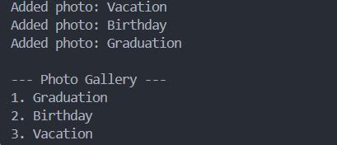

TASK 5
#include <iostream>
using namespace std;

class Node {
public:
string data;
Node *next;

Node(string t) : data(t), next(nullptr) {}
};

class InventoryManagement {
private:
Node *head, *tail;

public:
InventoryManagement() : head(nullptr), tail(nullptr) {}

void addItemInOrder(string item) {
Node *newNode = new Node(item);
if (!head) {
head = tail = newNode;
} else {
Node *temp = head, *prev = nullptr;
while (temp && temp->data < item) {
prev = temp;
temp = temp->next;
}
if (!prev) {
newNode->next = head;
head = newNode;
} else {
prev->next = newNode;
newNode->next = temp;
if (!temp) tail = newNode;
}
}
cout << "Added item: " << item << endl;
}

void display() {

int pos = 1;
Node* temp = head;
cout << "\n--- Inventory Items ---\n";
if (!head) {
cout << "(empty)\n";
return;
}
while (temp) {
cout << pos << ". " << temp->data << endl;
temp = temp->next;
pos++;
}
}
};

int main() {
InventoryManagement inventory;
inventory.addItemInOrder("100");
inventory.addItemInOrder("104");
inventory.addItemInOrder("102");
inventory.addItemInOrder("101");
inventory.display();
return 0;
}

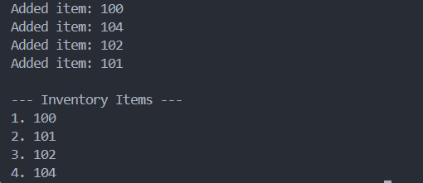

TASK 6
#include <iostream>
using namespace std;

class Node {
public:
string data;
Node *next;

Node(string t) : data(t), next(nullptr) {}
};

class TaskList {
public:
Node *head;
Node *tail;

TaskList() : head(nullptr), tail(nullptr) {}

void addTask(const string &task) {
Node *newNode = new Node(task);
if (!head) {
head = tail = newNode;
} else {
tail->next = newNode;
tail = newNode;
}
}

void print() {
Node *temp = head;
int pos = 1;
while (temp) {
cout << pos << ": " << temp->data << endl;
temp = temp->next;
pos++;
}
cout << endl;
}
};

TaskList mergeTaskLists(TaskList &list1, TaskList &list2) {
TaskList merged;
Node *temp = list1.head;
while (temp) {
merged.addTask(temp->data);
temp = temp->next;
}
temp = list2.head;
while (temp) {
merged.addTask(temp->data);
temp = temp->next;
}
return merged;
}

int main() {
TaskList list1, list2;
list1.addTask("assignment");
list1.addTask("code");
list1.addTask("grocery");

list2.addTask("laundry");
list2.addTask("cleaning");

cout << "-- List 1 --\n";
list1.print();
cout << "-- List 2 --\n";
list2.print();

TaskList mergedList = mergeTaskLists(list1, list2);
cout << "\n--- Merged List ---\n";
mergedList.print();

return 0;
}

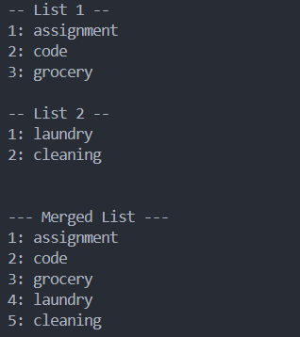
TASK 7
#include <iostream>
using namespace std;

class Node {
public:
string data;
Node *next;

Node(string t) : data(t), next(nullptr) {}
};

class RideManagement {
Node *head;
Node *tail;
int totalSeats;

public:
RideManagement(int n) : head(nullptr), tail(nullptr), totalSeats(n) {
if (n <= 0) return;
head = new Node("Seat 1: Available");
Node *curr = head;
for (int i = 2; i <= n; ++i) {
curr->next = new Node("Seat " + to_string(i) + ": Available");
curr = curr->next;
}
tail = curr;
tail->next = head;
}

~RideManagement() {
if (!head) return;
Node *curr = head->next;
while (curr != head) {
Node *temp = curr;
curr = curr->next;
delete temp;
}
delete head;
tail = nullptr;
}

bool reserveSeat(int seatNum) {
if (!head || seatNum < 1 || seatNum > totalSeats) return false;
Node *curr = head;
for (int i = 1; i <= totalSeats; ++i) {
if (i == seatNum) {
if (curr->data.find("Available") != string::npos) {
curr->data = "Seat " + to_string(seatNum) + ": Reserved";
return true;
} else {
return false;
}
}
curr = curr->next;
}
return false;
}

bool cancelReservation(int seatNum) {
if (!head || seatNum < 1 || seatNum > totalSeats) return false;
Node *curr = head;
for (int i = 1; i <= totalSeats; ++i) {
if (i == seatNum) {
if (curr->data.find("Reserved") != string::npos) {
curr->data = "Seat " + to_string(seatNum) + ": Available";
return true;
} else {
return false;
}
}
curr = curr->next;
}
return false;
}

void displaySeats() {
if (!head) {
cout << "No seats available.\n";
return;
}
Node *curr = head;
cout << "\n--- Ride Seat Reservations ---\n";
for (int i = 1; i <= totalSeats; ++i) {
cout << curr->data << endl;
curr = curr->next;
}
}
};

int main() {
int n;
cout << "Enter number of ride seats: ";
cin >> n;
RideManagement ride(n);

int choice, seatNum;
do {
cout << "\n1. Reserve Seat\n2. Cancel Reservation\n3. Display Seats\n0. Exit\nEnter choice: ";
cin >> choice;
switch (choice) {
case 1:
cout << "Enter seat number to reserve: ";
cin >> seatNum;
if (ride.reserveSeat(seatNum))
cout << "Seat reserved successfully.\n";
else
cout << "Seat reservation failed.\n";
ride.displaySeats();
break;
case 2:
cout << "Enter seat number to cancel reservation: ";
cin >> seatNum;
if (ride.cancelReservation(seatNum))
cout << "Reservation cancelled.\n";
else
cout << "Cancellation failed.\n";
ride.displaySeats();
break;
case 3:
ride.displaySeats();
break;
case 0:
cout << "Exiting...\n";
break;
default:
cout << "Invalid choice.\n";
}
} while (choice != 0);

return 0;
}

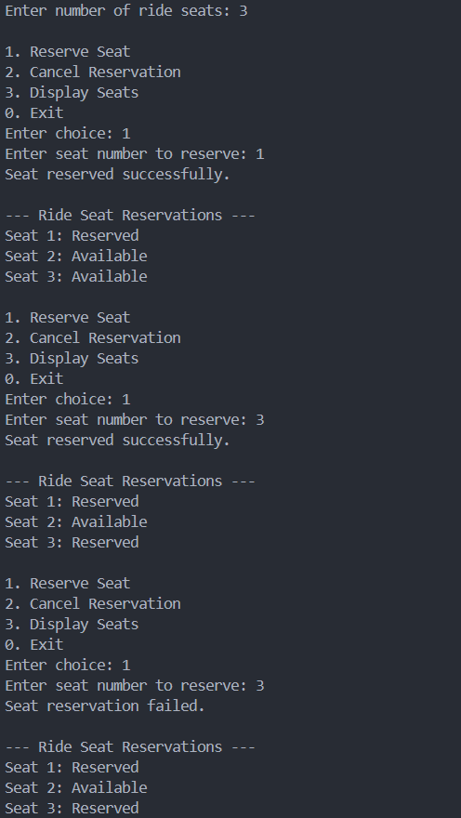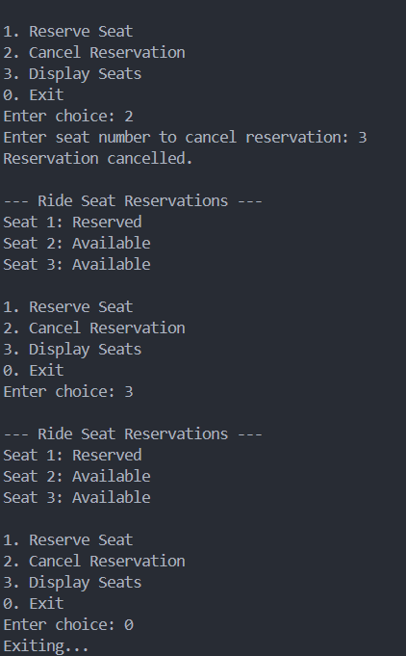

TASK 8
#include <iostream>
using namespace std;

struct Node {
int data;
Node* prev;
Node* next;
Node(int val) : data(val), prev(nullptr), next(nullptr) {}
};

class DoublyLinkedList {
private:
Node* head;
Node* tail;
public:
DoublyLinkedList() : head(nullptr), tail(nullptr) {}

void insertAtEnd(int val) {
Node* newNode = new Node(val);
if (!head) {
head = tail = newNode;
} else {
tail->next = newNode;
newNode->prev = tail;
tail = newNode;
}
}

void deleteAtFront() {
if (!head) return;
Node* temp = head;
head = head->next;
if (head) {
head->prev = nullptr;
} else {
tail = nullptr;
}
delete temp;
}

bool search(int val) {
Node* temp = head;
while (temp) {
if (temp->data == val) return true;
temp = temp->next;
}
return false;
}

void display() {
Node* temp = head;
while (temp) {
cout << temp->data << " ";
temp = temp->next;
}
cout << endl;
}
};

int main() {
DoublyLinkedList doubly;
doubly.insertAtEnd(10);
doubly.insertAtEnd(20);
doubly.insertAtEnd(30);
cout << "List: ";
doubly.display();

cout << "Search 20: " << (doubly.search(20) ? "Found" : "Not Found") << endl;
cout << "Search 40: " << (doubly.search(40) ? "Found" : "Not Found") << endl;

doubly.deleteAtFront();
cout << "After deleting front: ";
doubly.display();

return 0;
}

